Department of Artificial Intelligence and Machine Learning
Object Oriented Programming through C++ (2501CS08)
STUDENT ATTENDANCE MARKING SYSTEM
CERTIFICATE

BATCH NUMBER – 01
SUBMITTED BY

PALAMANI CHENCHU MAHESH — 25B11AI875
AKSHINTALA DEVI SRI CHARAN — 25B11AI018
PILLI LOKESH — 25B11AI955
GORLI KUSA RAJU — 26B21AI004

In partial fulfilment of the requirements for the award of the B.Tech. degree in Artificial intelligence and machine learning the academic year 2026-2027.

Project Guide Head of the Department
Thorati Vijaya lakshmi, Dr. K. Naga Bhargavi, Ph.D,
Assistant Professor, Associate Professor & HOD,
Department of AIML. Department of AIML.


CERTIFICATE
This is to certify that the cornerstone project entitled “STUDENT ATTENDANCE MARKING SYSTEM” is submitted by PALAMANI CHENCHU MAHESH (25B11AI875), AKSHINTALA DEVI SRI CHARAN (25B11AI018), PILLI LOKESH (25B11AI955), and GORLI KUSA RAJU (26B21AI004), in partial fulfilment of the requirements for the award of the B.Tech Degree in Artificial Intelligence and Machine Learning at Aditya University.
This project has been carried out as part of the Object-Oriented Programming through C++ course under the guidance of the concerned faculty member.
The project demonstrates the application of C++ programming concepts to develop a basic student attendance marking system.

Project Guide
T.VIJAYALAKSHMI, M.Tech
Assistant Professor
Department of Artificial Intelligence and Machine Learning
Aditya University

DECLARATION
We hereby declare that the cornerstone project entitled “STUDENT ATTENDANCE MARKING SYSTEM” is submitted by us in partial fulfilment of the requirements for the award of the B.Tech Degree in Artificial Intelligence and Machine Learning at Aditya University.
We declare that this project demonstrates the implementation of a student attendance marking system using the C++ programming language and object-oriented programming concepts.
We have worked together in designing, implementing, testing, and documenting the project.
Submitted By:
- PALAMANI CHENCHU MAHESH — 25B11AI875
- AKSHINTALA DEVI SRI CHARAN — 25B11AI018
- PILLI LOKESH — 25B11AI955
- GORLI KUSA RAJU — 26B21AI004
Place: Surampalem
Date: __________________

ACKNOWLEDGEMENT

It is with immense pleasure that we express our sincere gratitude to our Cornerstone Project Guide, , T.VIJAYALAKSHMI, M.Tech ,Assistant Professor, who has guided us throughout the project. Valuable support, encouragement, and guidance have greatly contributed to the successful completion of this work.
We would like to thank our Deputy Heads of the Department, Dr. R. Suneetha, Assistant Professor, Dr.Bollu ManikyalaRao, Associate Professor ,Dr.D.Veeraswamy,Assistant Professor Department of AIML, for their support and valuable suggestions.
Our deepest thanks to our Head of the Department Dr. . K.Naga Bhargavi, Associate Professor,
for her inspiration and for providing all the necessary facilities and resources required for this project.
We also extend our sincere thanks to Dr. M.V. Rajesh, Associate Dean, School of Computing for their encouragement and support during the course of our project.
We would like to express our sincere gratitude to Dr. G. Suresh, Registrar, Dr. A Ramesh, Pro Vice-Chancellor (Engineering & Sciences), Dr.S. Rama S r e e , Pro Vice-Chancellor (Academics), D r . M.B. Srinivas, V i c e -Chancellor, Dr. M. Sreenivasa Reddy, Deputy Pro Chancellor and Management, Aditya University for providing excellent infrastructure and state-of-the-art laboratories.
Finally, we would like to thank the faculty members, lab technicians, non-teaching staff, and our friends who have directly or indirectly supported us in completing this Cornerstone project successfully

- PALAMANI CHENCHU MAHESH — 25B11AI875
- AKSHINTALA DEVI SRI CHARAN — 25B11AI018
- PILLI LOKESH — 25B11AI955
- GORLI KUSA RAJU — 26B21AI004
Date: ____________________

ABSTRACT

The Student Attendance Marking System is a menu-driven application developed using C++. The main purpose of this project is to simplify the process of maintaining student attendance records.
The system allows the user to enter student details, including roll number and name. It provides options to display all registered students, mark attendance, search for a student using the roll number, and exit the application.
The project uses a Student class to organize student information and attendance-related operations. An array of student objects is used to store the details of multiple students during program execution.
The system demonstrates important object-oriented programming concepts, including classes, objects, encapsulation, data members, member functions, and arrays of objects.
This project provides a simple and understandable approach to student attendance management and can be extended in the future with attendance percentage calculation, date-wise attendance records, file handling, and database integration.

ABBREVIATIONS

Abbreviation | Meaning
OOP | Object-Oriented Programming
C++ | C++ Programming Language
UI | User Interface
I/O | Input / Output
ID | Identification
CSV | Comma-Separated Values
TXT | Plain Text File
PBL | Project Based Learning
API | Application Programming Interface

LIST OF FIGURES

• Overall System Architecture
• Student Class Structure
• Student Registration Flowchart
• Attendance Marking Flowchart
• Student Search Flowchart
• Main Menu and Program Flow
• Student Registration Output
• Display Students Output
• Mark Attendance Output
• Student Search Output
• Student Not Found Output
- percentage calculation and low-attendance report.
• Program Exit Output
LIST OF TABLES

Table 1 – Planned Modules / Functions
Table 2 – OOP Concepts and Their Use in the Code
Table 3 – Student Class Description
Table 4 – System Inputs and Outputs
Table 5 – Test Cases and Expected Results
Table 6 – Team Members and Responsibilities

TABLE OF CONTENTS

Preliminary Pages
- Title Page
- Certificate
- Declaration
- Acknowledgement
- Abstract
- Abbreviations
- List of Figures
- List of Tables
- Table of Contents
CHAPTER 1 – PROJECT PLANNING
1.1 Problem Statement
1.2 Project Objectives
1.3 Planned Modules
1.4 System Architecture
1.5 Algorithm
CHAPTER 2 – PROJECT IMPLEMENTATION
2.1 Programming Language and Tools
2.2 OOP Concepts Used
2.3 Source Code
2.4 Explanation of the Code
2.5 Output Screens
2.6 Test Cases
CHAPTER 3 – CONCLUSION AND FUTURE SCOPE
3.1 Conclusion
3.2 Future Scope
References
Appendix – Team Members and Responsibilities

CHAPTER 1
PROJECT PLANNING
1.1 Problem Statement
Maintaining student attendance manually can be time-consuming and difficult when handling multiple students. Searching for individual student details and updating attendance records manually may also lead to errors.
The Student Attendance Marking System addresses this problem by providing a simple, menu-driven C++ application.
The system stores student roll numbers and names, displays registered student details, allows attendance to be marked, and provides a search facility using the student's roll number.
This project demonstrates how programming can simplify basic attendance-related operations.
1.2 Project Objectives
The main objectives of the project are:
- To develop a simple student attendance marking system using C++.
- To store student roll numbers and names.
- To initialize the attendance count for every student.
- To display the details of all registered students.
- To mark attendance for a student using their roll number.
- To search for a student using the roll number.
- To display an appropriate message when a student is not found.
- To apply object-oriented programming concepts.
- To provide a user-friendly menu for performing different operations.
1.3 Planned Modules
The system is divided into the following modules.

.
Module | Function | Main Operations
Student Registration | addStudent(). | Accepts the student's roll number and name.
Student Identification | getRollNo() | Returns the roll number of a student.
Attendance Marking | markAttendance() | Present / Absent status
Student Display | displayStudent() | Displays student details and present days.
Student Search | getRollNo() with a loop | Searches for a student using the roll number.
Percentage Calculation | GetAttendancePercentage() | calculates the attendance percentage.
Low Attendance Report | displayIfBelow75() | displays students whose attendance percentage is below 75%.

1.4.1 Three-Layer Architecture

The project follows a simple console-based architecture.
Input Layer
The user enters student details, roll numbers, and menu choices through the keyboard.
Processing Layer
The Student class processes student information and attendance operations. The main() function controls the program flow and executes the selected operation.
Output Layer
The system displays student details, attendance confirmation messages, search results, and menu options on the console.
. 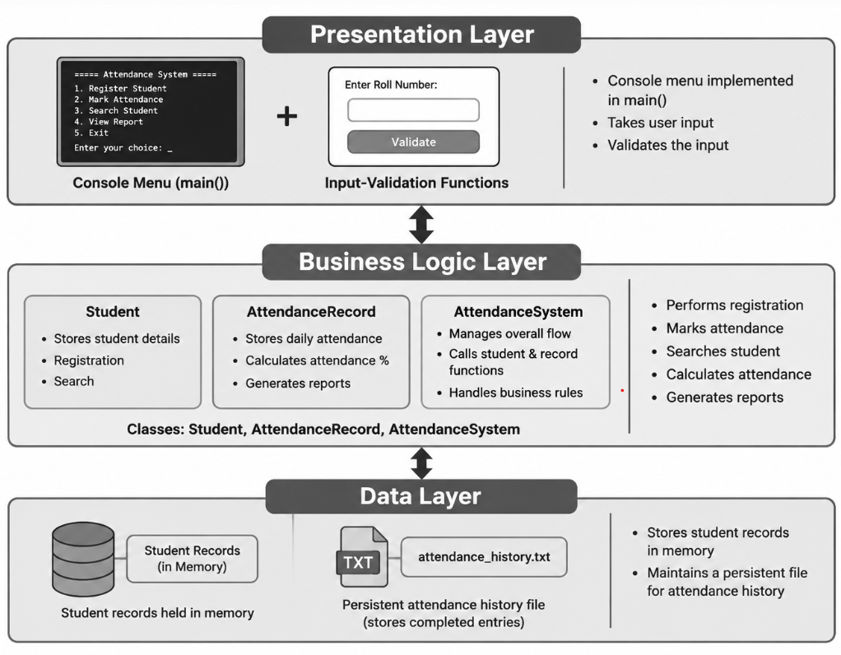

Figure 1 – Overall System Architecture

1.4.2 Overall Processing Flow
User Input → Main Menu → Student Class Operations → Process Student Data → Display Output
The program stores student information in an array of Student objects during execution.
1.5 Algorithm
A. Student Registration Algorithm
- Start the program.
- Read the number of students.
- For each student, accept the roll number.
- Accept the student's name.
- Initialize the attendance count to zero.
- Store the details in the corresponding array object.
- Repeat until all students are registered.
B. Display Students Algorithm
- Select the Display Students option.
- Traverse the array of registered students.
- Call displayStudent() for each student.
- Display the roll number, name, and present days.
- Return to the main menu.
C. Mark Attendance Algorithm
- Select the Mark Attendance option.
- Enter the roll number of the student.
- Compare the entered roll number with the registered students.
- If a matching roll number is found, call markAttendance().
- Increase the student's attendance count by one.
- Display the success message.
- If no matching student is found, display “Student Not Found!”
- Return to the main menu.
D. Search Student Algorithm
- Select the Search Student option.
- Enter the roll number to search.
- Compare it with each registered student's roll number.
- If a match is found, display the student's details.
- If no match is found, display “Student Not Found!”
- Return to the main menu.
E. Exit Algorithm
- Select option 4.
- Display the thank-you message.
- Terminate the menu loop.
- End the program.

CHAPTER 2
PROJECT IMPLEMENTATION

2.1 OOP Concepts Used for Implementation
The program is written in C++ and is organized around Student, AttendanceRecord and AttendanceSystem classes. The following table summarizes the object-oriented concepts used in the implementation.
1. Class
A class is a user-defined data type that combines data members and member functions.
In this project, the Student class stores student information and provides functions to manage attendance.
2. Object
An object is an instance of a class.
The statement Student s[10]; creates an array of ten Student objects. Each object represents one student.
3. Encapsulation
Encapsulation combines data and functions into a single unit.
In this project, the data members rollNo, name, and attendance are declared under private. They are accessed through public member functions.
4. Data Members
Data members store the information associated with an object.
The project contains three data members:
- rollNo – stores the student's roll number.
- name – stores the student's name.
- attendance – stores the number of times attendance has been marked.
5. Member Functions
Member functions define the operations that can be performed on an object.
The project uses the following member functions:
- addStudent()
- getRollNo()
- markAttendance()
- displayStudent()
- getAttendancePercentage()
- displayIfBelow75()
6. Array of Objects
An array of objects stores multiple objects of the same class.
The statement Student s[10]; allows the program to store details for up to ten students.
7. Conditional Statements
The if statement checks whether the entered roll number matches a registered student.
The switch statement executes the operation selected from the main menu.
8. Loops
The for loop is used to register students, display their details, and search for a matching roll number.
The do-while loop repeatedly displays the menu until the user selects option 4.

Source Code: StudentAttendanceManagement.cpp

File Name: StudentAttendanceMarking.cpp

#include <iostream>
#include <limits>
using namespace std;

class Student
{
private:
int rollNo;
char name[30];
int attendance;

public:

// Add student details
void addStudent()
{
while (true)
{
cout << "\nEnter Roll Number: ";

if (cin >> rollNo)
{
break;
}
else
{
cout << "Invalid Roll Number! Please enter numbers only.\n";
cin.clear();
cin.ignore(numeric_limits<streamsize>::max(), '\n');
}
}

cout << "Enter Student Name: ";
cin >> name;

attendance = 0;
}

// Get roll number
int getRollNo()
{
return rollNo;
}

// Mark attendance
void markAttendance()
{
attendance++;
cout << "Attendance Marked Successfully!\n";
}

// Calculate attendance percentage
float getAttendancePercentage(int totalDays)
{
if (totalDays == 0)
return 0;

return (attendance * 100.0) / totalDays;
}

// Display student details
void displayStudent()
{
cout << "\nRoll Number : " << rollNo;
cout << "\nName : " << name;
cout << "\nPresent Days: " << attendance << endl;
}

// Display students having attendance below 75%
void displayIfBelow75(int totalDays)
{
float percentage = getAttendancePercentage(totalDays);

if (percentage < 75)
{
displayStudent();

cout << "Attendance Percentage: "
<< percentage << "%" << endl;
}
}
};

int main()
{
Student s[10];

int n, choice, roll, i, totalDays;
char present;

// Enter number of students
while (true)
{
cout << "Enter Number of Students: ";

if (cin >> n && n > 0 && n <= 10)
{
break;
}
else
{
cout << "Invalid input! Enter a number between 1 and 10.\n";
cin.clear();
cin.ignore(numeric_limits<streamsize>::max(), '\n');
}
}

// Add student details
for (i = 0; i < n; i++)
{
cout << "\nEnter Details of Student " << i + 1 << endl;
s[i].addStudent();
}

// Menu
do
{
cout << "\n==============================";
cout << "\n STUDENT ATTENDANCE SYSTEM";
cout << "\n==============================";
cout << "\n1. Display Students";
cout << "\n2. Mark Attendance";
cout << "\n3. Search Student";
cout << "\n4. Exit";
cout << "\n5. Calculate Attendance Percentage";
cout << "\n6. Students Below 75%";
cout << "\nEnter Your Choice: ";

// Validate menu choice
if (!(cin >> choice))
{
cout << "\nInvalid Choice! Please enter a number.\n";

cin.clear();
cin.ignore(numeric_limits<streamsize>::max(), '\n');

continue;
}

switch (choice)
{
// Display all students
case 1:

for (i = 0; i < n; i++)
{
s[i].displayStudent();
cout << "----------------------";
}

break;

// Mark attendance for ALL students
case 2:

cout << "\n===== MARK ATTENDANCE =====\n";

for (i = 0; i < n; i++)
{
s[i].displayStudent();

while (true)
{
cout << "Is the student present? (Y/N): ";
cin >> present;

if (present == 'Y' || present == 'y')
{
s[i].markAttendance();
break;
}
else if (present == 'N' || present == 'n')
{
cout << "Student marked Absent.\n";
break;
}
else
{
cout << "Invalid input! Please enter Y or N.\n";
}
}

cout << "----------------------\n";
}

cout << "\nAttendance completed for all students!\n";

break;

// Search student
case 3:

while (true)
{
cout << "\nEnter Roll Number: ";

if (cin >> roll)
{
break;
}
else
{
cout << "Invalid Roll Number! Please enter numbers only.\n";

cin.clear();
cin.ignore(numeric_limits<streamsize>::max(), '\n');
}
}

for (i = 0; i < n; i++)
{
if (s[i].getRollNo() == roll)
{
s[i].displayStudent();
break;
}
}

if (i == n)
{
cout << "Student Not Found!\n";
}

break;

// Exit
case 4:

cout << "\nThank You!\n";
break;

// Calculate attendance percentage
case 5:

while (true)
{
cout << "\nEnter Total Working Days: ";

if (cin >> totalDays && totalDays > 0)
{
break;
}
else
{
cout << "Invalid input! Enter a positive number.\n";

cin.clear();
cin.ignore(numeric_limits<streamsize>::max(), '\n');
}
}

for (i = 0; i < n; i++)
{
s[i].displayStudent();

cout << "Attendance Percentage: "
<< s[i].getAttendancePercentage(totalDays)
<< "%";

cout << "\n----------------------";
}

break;

// Display students below 75%
case 6:

while (true)
{
cout << "\nEnter Total Working Days: ";

if (cin >> totalDays && totalDays > 0)
{
break;
}
else
{
cout << "Invalid input! Enter a positive number.\n";

cin.clear();
cin.ignore(numeric_limits<streamsize>::max(), '\n');
}
}

cout << "\nStudents Having Attendance Below 75%:\n";

for (i = 0; i < n; i++)
{
s[i].displayIfBelow75(totalDays);

cout << "\n----------------------";
}

break;

// Invalid choice
default:

cout << "\nInvalid Choice!\n";
}

} while (choice != 4);

return 0;
}
2.4 Explanation of the Code
Student Class
The Student class contains the data members rollNo, name, and attendance.
These variables store the student's roll number, name, and attendance count.
addStudent()
This function reads the student's roll number and name. It initializes the attendance count to zero.
getRollNo()
This function returns the roll number of the current student object. The main program uses it to locate a student.
markAttendance()
This function increments the attendance count by one and displays a success message.
displayStudent()
This function displays the student's roll number, name, and number of present days.
getAttendancePercentage()
function calculates the attendance percentage.
displayIfBelow75()
function displays students whose attendance percentage is below 75%.

main()
The main() function creates an array of student objects and accepts the number of students.
It collects the details of each student and displays a menu containing four options.
The switch statement executes the selected operation. The do-while loop repeats the menu until the user chooses Exit.
2.5 Output Screens
Capture and insert screenshots of the actual program output under the following headings.
Figure 1: Student Registration
The program asks for the number of students and accepts the roll number and name of each student.
Figure 2: Main Menu
The program displays the following menu:
==============================
STUDENT ATTENDANCE SYSTEM
==============================
1. Display Students
2. Mark Attendance
3. Search Student
4.Calculate Attendance Percentage.
5.Students Below 75%.
6.Exit
Enter Your Choice:
Figure 3: Display Students
When the user selects option 1, the program displays the roll number, name, and present days of every registered student.
Figure 4: Mark Attendance
When the user selects option 2, the program asks for a roll number.
If the roll number matches a registered student, the attendance count increases by one and the program displays:
Attendance Marked Successfully!
Figure 5: Search Student
When the user selects option 3 and enters a registered roll number, the program displays that student's details.
Figure 6: Student Not Found
If the entered roll number does not match any registered student, the program displays:
Student Not Found!
Figure 7: Exit
When the user selects option 4, the program displays:
Thank You!
The program then terminates.
Figure 7 –Add Student
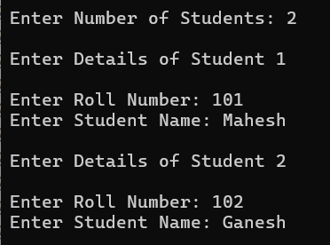
Figure 8 – Mark Attendance
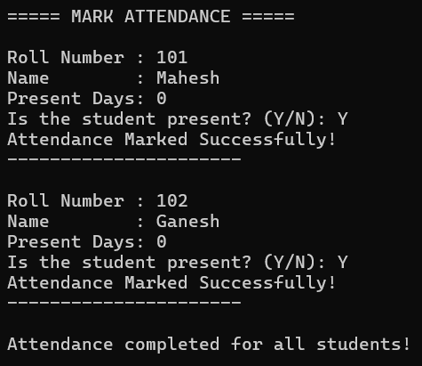

Figure 9 – Search and View Attendance
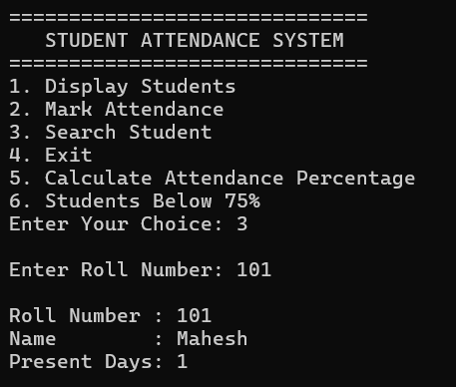

Figure 10 – View Attendance Summary
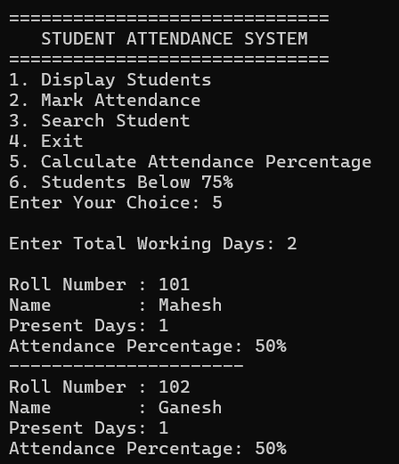

Figure 11 – View Low Attendance Students
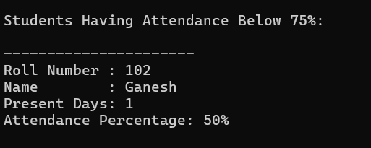

Figure 12 – Show Total Students
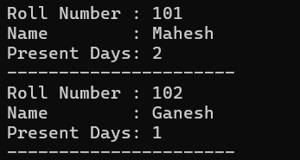

Figure 13 – Exit
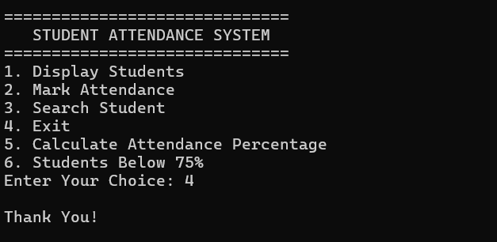

2.6 Test Cases
Test Case | Input or Operation | Expected Result
Student Registration | Enter valid student details | Student details are stored in the object.
Display Students | Select option 1 | All registered students are displayed.
Mark Attendance | Enter a registered roll number | Attendance count increases by one.
Search Student | Enter an existing roll number | Matching student details are displayed.
Search Invalid Roll Number | Enter an unregistered roll number | “Student Not Found!” is displayed.
Invalid Menu Choice | Enter an unsupported menu option | “Invalid Choice!” is displayed.
Exit Program | Select option 4 | “Thank You!” is displayed and the menu loop ends.
The test cases should be executed with actual inputs, and the observed results should be checked before the report is submitted.

CHAPTER 3
CONCLUSION & FUTURE SCOPE

3.1 Conclusion
The Student Attendance Marking System demonstrates the use of C++ programming to simplify basic student attendance operations.
The system provides student registration, student display, attendance marking, and student search facilities through a menu-driven interface.
The project applies important object-oriented programming concepts, including classes, objects, encapsulation, member functions, and arrays of objects.
The project helped us understand how C++ concepts can be used to develop a practical application. The current implementation provides a foundation for developing a more advanced attendance management system.
3.2 Future Scope
The project can be improved by adding the following features:
- Attendance Percentage: Calculate attendance percentages automatically.
- Date-Wise Attendance: Store attendance for individual dates.
- Present and Absent Status: Allow the user to mark students as either present or absent.
- File Handling: Save student details and attendance records permanently.
- Database Integration: Store student information in a database.
- Input Validation: Prevent invalid student counts and duplicate roll numbers.
- Attendance Reports: Generate daily, weekly, and monthly reports.
- Graphical User Interface: Develop a user-friendly interface.
- Login System: Provide separate access for faculty and administrators.
- Student Notifications: Notify students about their attendance status.

REFERENCES
1. B. Stroustrup, The C++ Programming Language, 4th ed., Addison-Wesley, 2013.
2. E. Balagurusamy, Object-Oriented Programming with C++, McGraw Hill Education.
3. H. Schildt, C++: The Complete Reference, 4th ed., McGraw-Hill.
4. C++ Reference, cppreference.com – https://en.cppreference.com
5. Course material: Object Oriented Programming through C++ (2501CS08), Aditya University.

APPENDIX
TEAM MEMBERS AND RESPONSIBILITIES
Roll No. | Name | Role / Responsibility
25B11AI875 | PALAMANI CHENCHU MAHESH | Student Registration + Student Class
25B11AI018 |  | Attendance marking and attendance display
  AKSHINTALA DEVI SRI CHARAN
25B11AI955 | PILLI LOKESH | Student search and menu operations
26B21AI004 | GORLI KUSA RAJU | Testing, documentation, and report preparation

